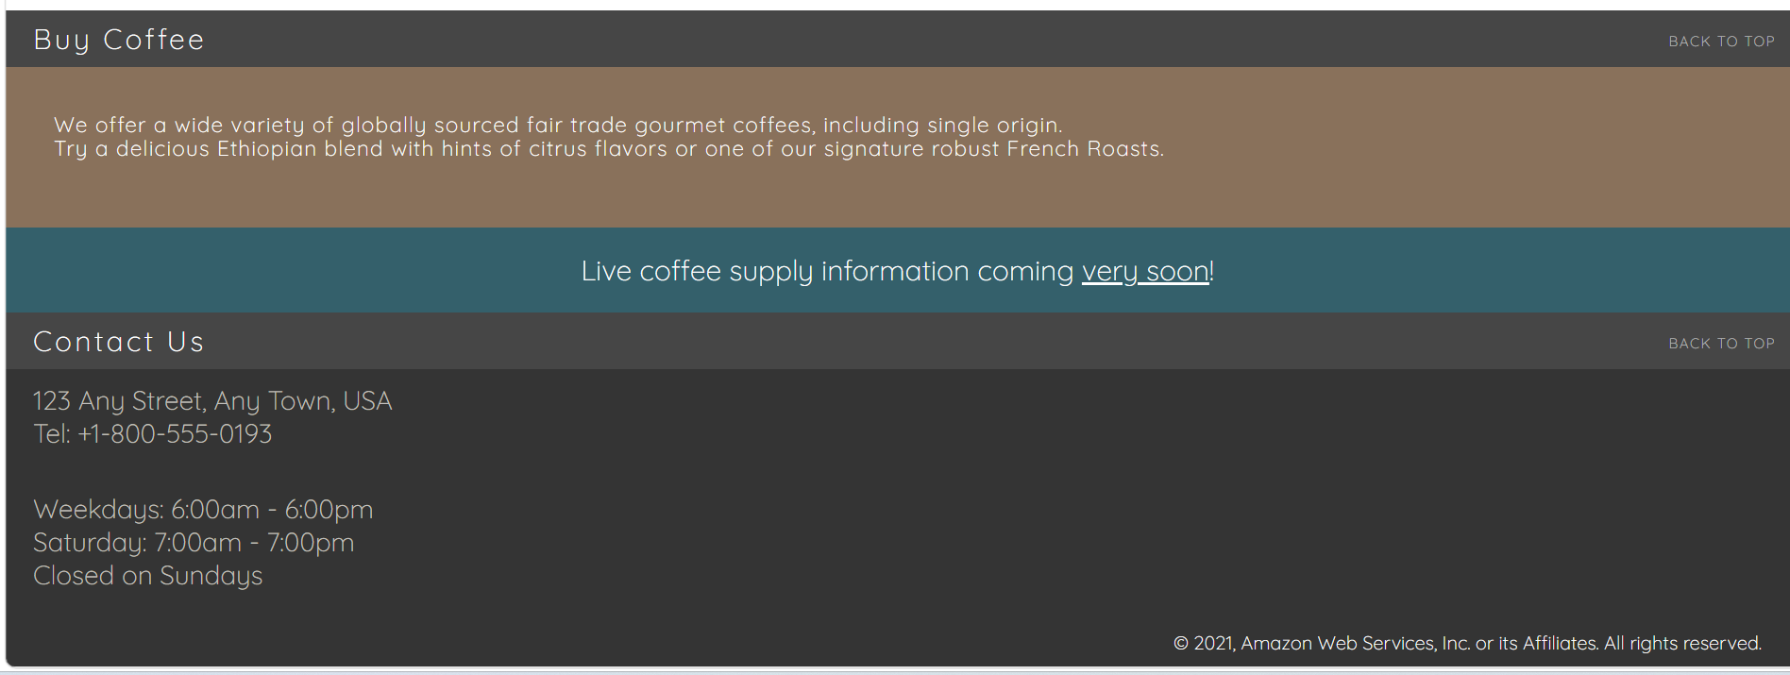

Back_To_Top for each part.

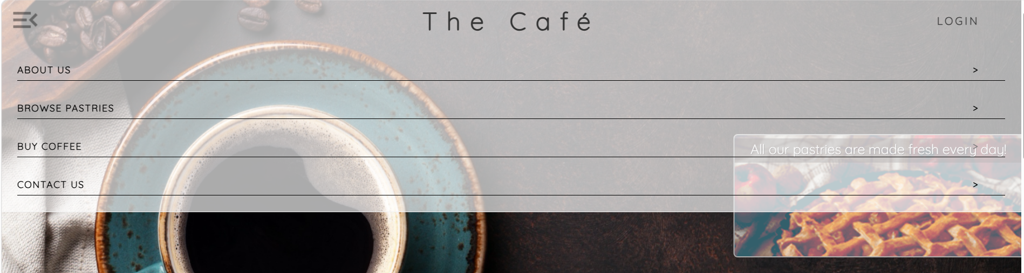

LOGIN
Hamburger Menu

About Us
Browse … -> On Offer View All

